**Deploy App Engine Standard Service**

1. Go to GCP console, search for app engine

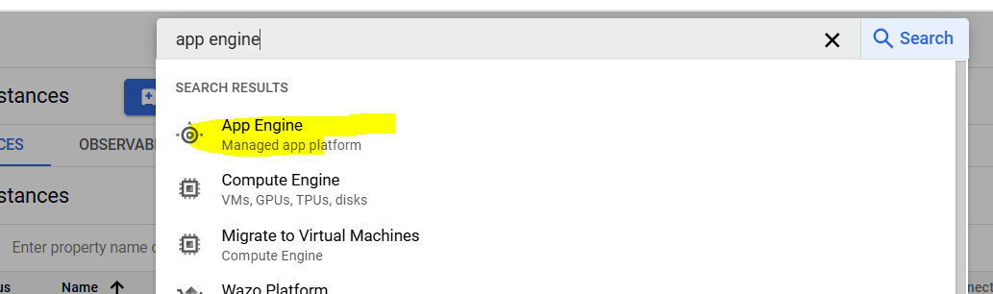

1. Click create application

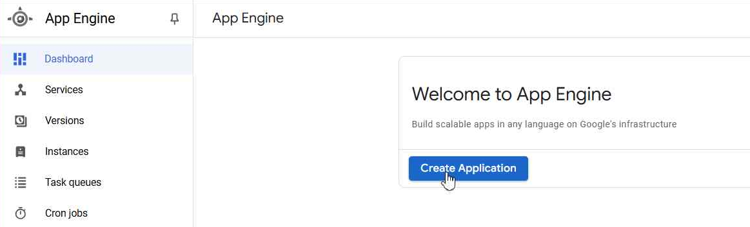

1. Select region and “App Engine default service account

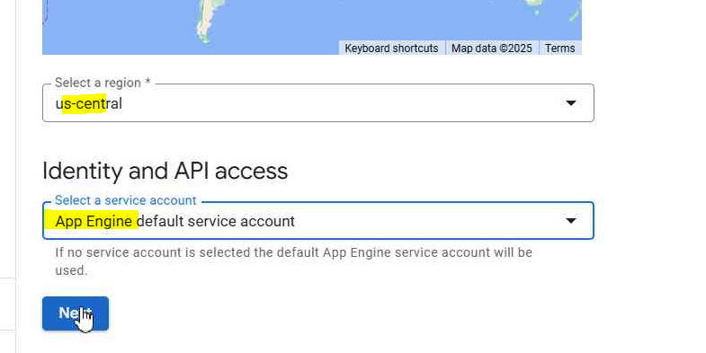

After clicking Next, it will take some time and once reach to next screen go to next step from there onwords

1. Now extract files from hello standardappengine file and save them to a folder
2. Do not change anything else on screen just open cloud shell in GCP

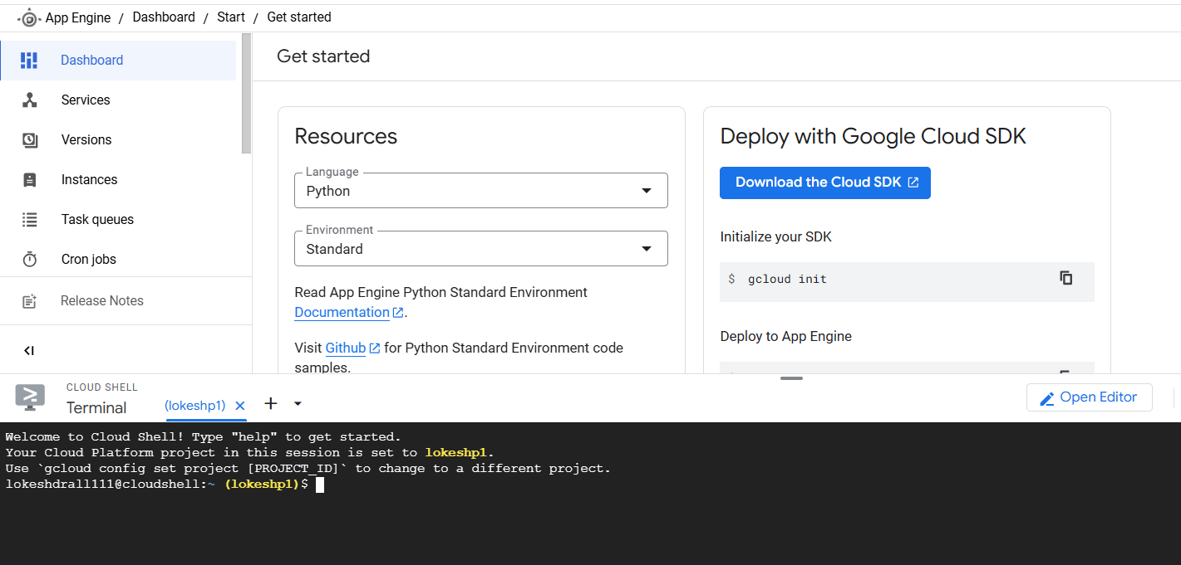

1. Now first we will test our code which we extracted from the folder, for that follow below
2. (Optional) Open the folder with these files in vscode, only go through the code
3. In cli, Make a new directory, type ~/helloworld, then go to this directory by typing cd ~/helloworld

Now if you do ls there, it will not show anything because it is a blank directory

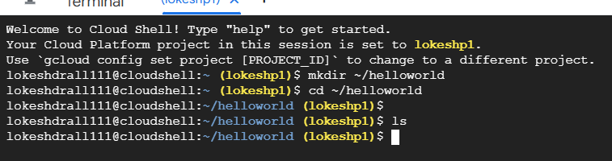

1. Upload our scripts to cli, for this click on three dots and click upload

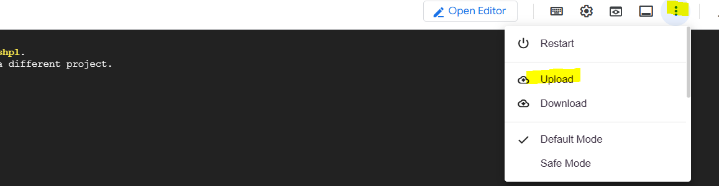

1. Select all three files, and in destination add folder name helloworld, destination will look like /home/lokeshdrall111/helloworld

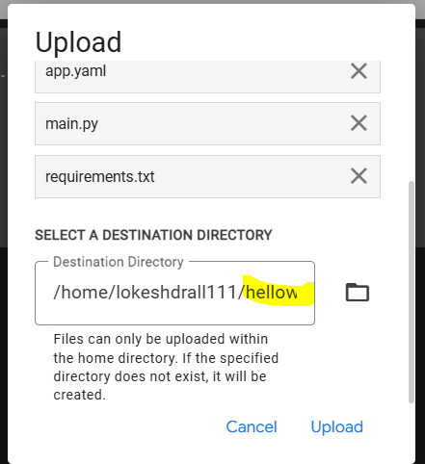

1. Again do ls and should be able to see the files

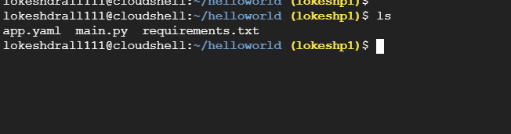

1. Run command python main.py (this should show like below, services running)

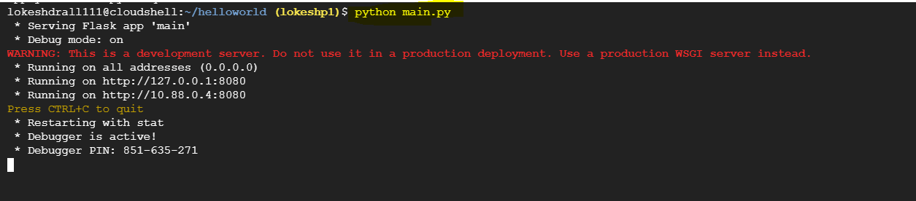

1. Click webpreview button and preview on port 8080

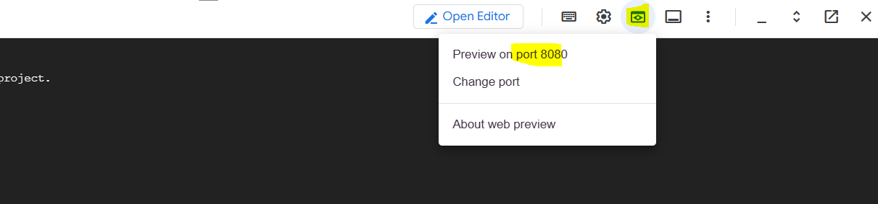

1. This will open a new webpage showing app is running

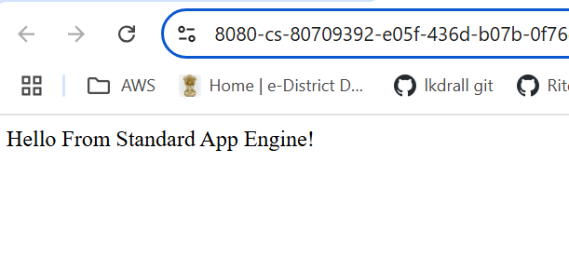

**Note, here so far we have just tested that our code is working fine.**

1. Ctrl+c on cli to stop session
2. Now to deploy the app, type gcloud app deploy in cli (make sure you are in helloworld directory)

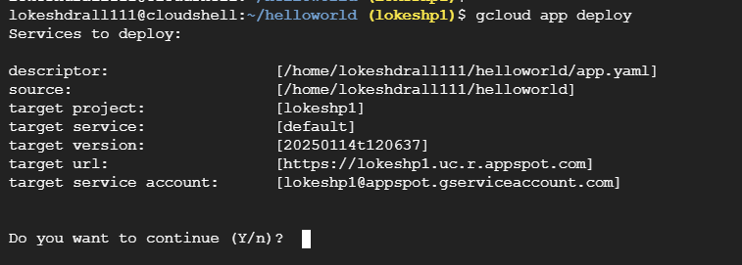

1. Type y and hit enter
2. This will take some time to complete, in case see any error like not access to bucket, run the same command again
3. Once complete successfully, it will show the deployed service url

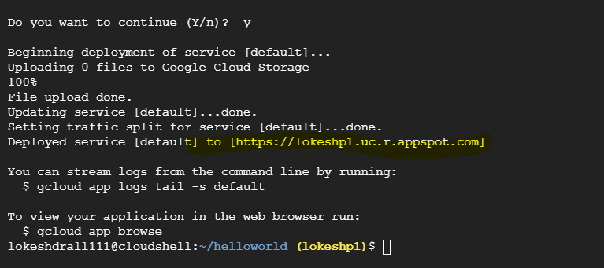

1. Copy the url and open in browser, webpage should open

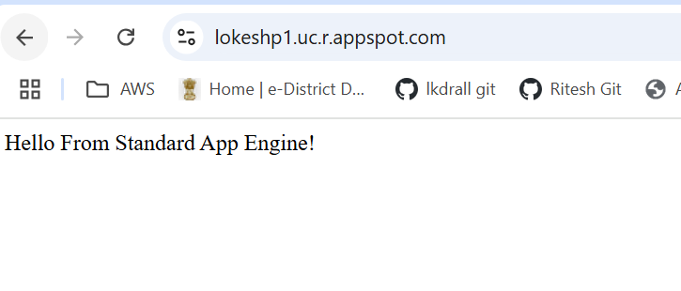

Now just check and explore options under Services and versions got created related to our application.

